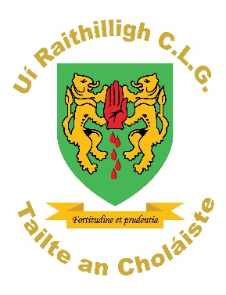
Collegeland O’Rahillys GAC

Notice of AGM - 2022
Call for Nominations & Motions
7/11/2022
A Chairde,

Collegeland O’Rahillys GAC will be holding their AGM on Sunday 20th November at 5pm.

You can now Nominate for the positions listed below and submit Motions to be considered. Before nominating anyone, you should ensure that they agree to let their name go forward for that position.

Nomination and Motions forms will be available, as below, for download from the club website and should be completed and returned to Rebecca McGeary, Rúnaí by Tuesday 15th November, or you can e-mail secretary.collegelandorahillys.armagh@gaa.ie.

The secretary’s report etc will be uploaded onto the club website in the same section.. However, any member who is unable to download these can contact me for a copy.

Is Mise Le Meas

Rebecca McGeary, Rúnaí
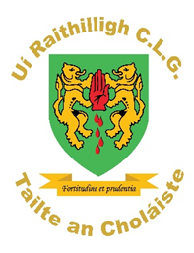
Collegeland O’Rahillys GAC
Nominations for 2022 AGM

Cathaoirleach (Chairperson) ………………………………………………………………….

Leas Cathaoirleach (Vice Chairperson) …..………………………………………………………………

Rúnaí (Secretary) …………………………………………………………………….

Leas Rúnaí (Assistant Secretary) …………………………………………………………………….

Cisteoir (Treasurer) …………………………………………………………………….

Leas Cisteoir (Assistant Treasurer) …………………………………………………………………….

Claraitheoir (Registrar) …………………………………………………………………….

Leas Claraitheoir (Assistant Registrar) …………………………………………………………………….

Oifigeach Chaidreamh Poiblí (PRO) …………………………………………………………………….

Oifigeach Cultúr (Cultural Officer) …………………………………………………………………….

Oifigeach Forbartha (Development Officer) ………………………………………………………………….

Oifigeach Gaeilge (Irish Officer)………………………………………………………………….

Oifigeach Gaeilge na hÓige (Youth Irish Officer) …………………………………………………

Baill na n-Imreorí (Players Representative) …………………………………………………………………….
Baill Eile (Additional Members) (5)

1 ……………………………………………………………………….

2 ……………………………………………………………………….

3 ………………..…………………………………………………….

4 …………..………………………………………………………….

5 …………..………………………………………………………….

Signithe. (Signed) ___________________________

Members Name ____________________________

Collegeland O’Rahillys GAC

Ruin. (Motions) for 2022 AGM

……………………………………………………………………………………………………………………………………………………………
……………………………………………………………………………………………………………………………………………………………
…………………………………………………………………………………………………………………………………………………………..
……………………………………………………………………………………………………………………………………………………………

……………………………………………………………………………………………………………………………………………………………
…………………………………………………………………………………………………………………………………………………………..
……………………………………………………………………………………………………………………………………………………………
….…………………………………………………………………………………………………………………………………………………………

Signithe. (Signed) ___________________________

Members Name PRINT ____________________________

This must be a current senior Footballer or someone who has played in the last 48 weeks.

